Welcome to Caithness Recovery Awareness Week
31st Aug-6th Sept 2019

in partnership with Caithness Drug and Alcohol Forum, Highland Alcohol and Drug Partnership, NHS Highland, Highland Council, UK SMART Recovery, AA, NA & Al-anon, Vocational Support and many more!

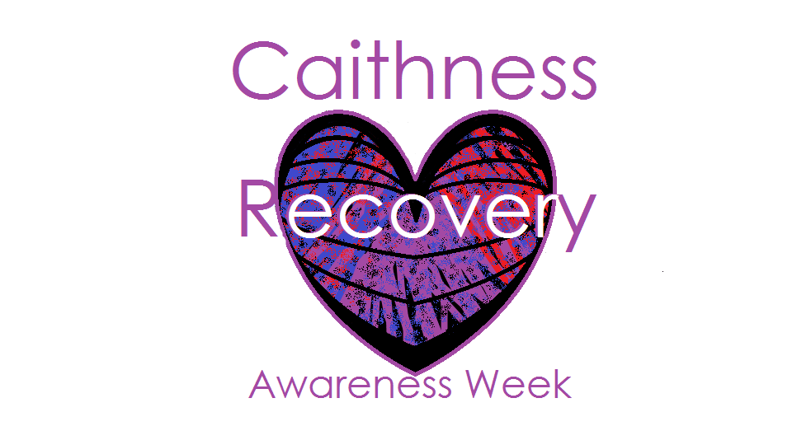
31st Aug-6th Sept 2019

Activities Calendar
Saturday 31st of August
10am-3pm Drug & Alcohol Information & Awareness stand, Tesco Wick
Sunday 1st September
6-7.30pm Road to Recovery addiction meeting Thurso Community Cafe
Monday 2nd September
10am-2pm Ripples Thurso Community Cafe, pop in for a chat, hot meal & cuppa
3-4pm Caithness Drug and Alcohol Forum Annual General Meeting Thurso Community Cafe.
4.30-5.30pm Loved and lost remembrance Thurso Community Cafe
6pm-8pm Drug and Alcohol Recovery Service Drop-in Evening, Caithness General Hospital Out Patients Dept, Wick.
8pm-9.30pm Al-anon Family Group Open Meeting Conference Room, Caithness General Hospital, Wick.

Activities Calendar
Wednesday 4th September
11am-1pm Drug and Alcohol Recovery Service Drop-in, Old Out Patients Dept, Dunbar Hospital, Thurso.
12 noon -1.30pm Alcoholics Anonymous Open Meeting in The Chapel, Caithness General Hospital, Wick.

Thursday 5th September
2pm-4pm Drug and Alcohol Recovery Service Drop-in, Old Medical Centre, Bankhead Road, Wick.
6.30pm Narcotics Anonymous Open Meeting in The Haven,

No booking required for any of the activities
listed, please feel free to turn up and get involved!

Training Calendar
Monday 2nd September
Naloxone, Overdose Awareness and Prevention Training 10.00-12.00 Thurso CMHT
Auricular Acupuncture for staff to come & Try 2.00-3.00 Thurso CMHT
Caithness Drug and Alcohol Forum Annual General Meeting Thurso Community Cafe 3.00-4.00.
Tuesday 3rd September
Discussing Drugs and Alcohol with Young People Training 12.30-4.30 North Highland College, Thurso
Wednesday 4th September
Working With Groups To Promote Health Training 9.30-4.30 PPP Wick.

Training Calendar
Thursday 5th September
NPS - New/Novel Psychoactive Substances Training 9.30-1.00 PPP Wick.
Auricular Acupuncture for staff to come & Try 2.00-3.00 Wick CMHT
Friday 6th September
Basic Drug & Alcohol Awareness Training 9.30-4.30 PPP, Wick.

Places on each of these courses are limited and booking is essential. To book please go to
(https://www.nhshighland.scot.nhs.uk/YourHealth/Pages/HealthImprovementTraining.aspx) complete the attached booking form clearly detailing which date and course you are applying for and send via post or email to the address at the bottom of the booking form.
For all information please contact Fiona Harper or Lesley Campbell
on 01955 606915 or 01847891224
or email to fiona.harper5@nhs.net or Lesley.campbell6@nhs.net

Please note booking is essential for all training

