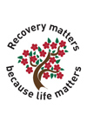

**Recovery Matters**

**Training for Trainers**

**Scottish Recovery Champions**

* **Lead / Study / Learning / facilitation**
* **5th Feb 18   Week 1 (Day 1) Orienteering, Information and online learning - Online Zoom (2hrs) 9.30-11.30 a.m.**
* **8th Feb 18 Week 1 (Day 2) Discussion Forum and Tasks - Online Zoom (2hrs) 9.30-11.30 a.m.**
* **13th Feb 18 Week 2 (Day 1) Full Day Workshop, 10.00  –  4.00  (6hrs) Venue : Inverness TBC**
* **14th Feb 18  Week 2  (Day 2)Full Day Workshop, 10 – 5.00 (7hrs) Venue: Inverness TBC**

## [**To**](http://scottishrecoveryconsortium.org.uk/index.php?id=2656) **book a place please email** [aileen.trappitt@nhs.net](mailto:aileen.trappitt@nhs.net)

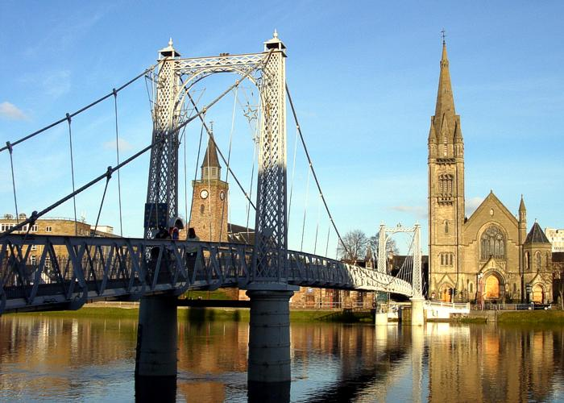

**Inverness 2018**

[**aileen.trappitt@nhs.net**](mailto:aileen.trappitt@nhs.net)

**This workshop is FREE from the point of delivery, but some participants may require overnight accommodation. Refreshments provided on both days.**