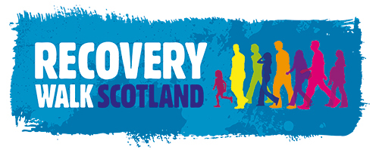

Recovery Village

On Saturday 21st September the Recovery Walk Scotland 2019 will take place in Inverness City Centre where we will have a beautiful space in which to create our own Recovery Village and celebration event.

Last year approx. 3,000 people in recovery, their friends and family across Scotland gathered in Glasgow to pay respect to those lost to addiction, walk and celebrate recovery. A large part of the day was provided by groups and organisations who set up in the Recovery Village and offered a range of different fun activities for participants, these included stalls offering free mocktails, photo booth, hair braiding, temporary tattoos, exhibitions, art space and complementary therapies to name a few.

What can you contribute to the celebration?
We are inviting groups, fellowships and organisations to build this year’s village by offering you free space in the park to bring your own gazebo or tent; in which you can offer something that adds to the celebration of recovery. This space should be somewhere that people can meet up, connect and hopefully try out something different. Our theme for the walk this year is ‘Compassionate Communities Create…’, with that in mind, what does this mean to you and your group and how can this help shape what you would like to contribute to the Recovery Village on the day?

This year we are hoping for an even more diverse village filled with your bright, moving, colourful, amusing and downright wacky contributions to the recovery celebrations. This will be biggest outdoor gathering of people in recovery in Scotland, their friends, families and allies - could you think of something to offer that will put a smile on people’s faces and a good memory in their hearts?
Things to avoid: leaflet/information only stalls, stalls that promote particular treatment services/businesses or stalls selling anything.

So how do you get a space in the park for your contribution?
Please complete the below application form and email this to Heather (heather@scottishrecoveryconsortium.org).

All Recovery Village requests will be submitted for the approval of the Recovery Walk council, following their confirmation you will be required to submit a Risk Assessment specific to your contribution on the day (a template can be provide, should you require this) and a copy of your Public Liability Insurance, if you need any assistance with either of these Heather will be more than happy to help with any information required, she can also be reached by phoning her direct line number 0141 559 6930.

We are looking forward to hearing from you and whatever you come up with!

Recovery Village Application
Contact Name:
Telephone Number:
Email Address:
Organisation/Group:
Recovery Village Offer:
Gazebo Size: | Length (in meters) |  |  |  |  | Width (in meters)
Due to council licensing we will require the following documentation in addition to your application, please advise if you are able to provide this information alongside your application, if the answer is no you must provide evidence of this prior to the event:
Do you have Public Liability Insurance? |  |  |  |  | Do you have a Risk Assessment?
Yes ☐ |  |  | No ☐ |  | Yes ☐ |  | No ☐
If you answered yes, please submit these documents with this application.

If you require power for any part of your activities could you please include details of this within your application above.

