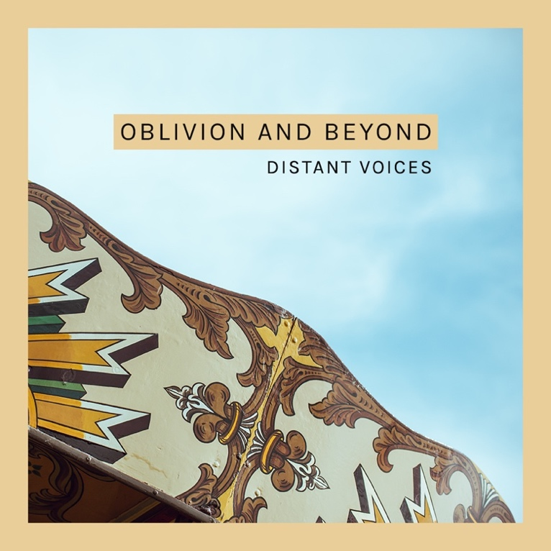

Oblivion and Beyond – exploring recovery through songs
Over the last two years, Vox Liminis has been working with local partners in the Highland area in areas of criminal justice, in a project called Distant Voices. More recently we’ve been working with HADP and others to support community approaches to reducing alcohol and drug related harm – including by engaging the local public in conversations about recovery and reintegration, to better understand the complexities of the recovery journey, decrease stigma and support reintegration.
In October, we were proud to present Oblivion and Beyond: a new 5-track EP from the Distant Voices project. Each song was co-written by people with personal and/or professional experience of drug use and recovery along with professional musicians. We hope that sharing stories in song can play a part in sparking conversations and changing our culture, so that we recognise drug and alcohol harm as issues of public health, inclusion and equality that affects – and is affected by – us all. Oblivion and Beyond offers an invitation and resource for a deeper public conversation about these issues.

In October, we shared these songs - and others – to the public at gigs in Inverness and Thurso, in HMP Inverness, and with members of the Recovery choir. The songs were also performed live in workshops with practitioners, which provided an opportunity for frontline workers to creatively explore their own practice and experiences.

Here’s some responses from our work in October:
This workshop has confirmed to me the importance of reducing stigma and instilling hope in my patients. Without having hope as a keyworker for our patients it could inhibit hope for them and in turn recovery. It is also important to see person for who they are rather than the person with addictive behaviour or offending behaviour. To encourage each individual to express themselves in any way possible is a form of escapism. – workshop participant
Learned lots but was also reminded why I love this job and how my professional role fundamentally connects with my values and beliefs. Key reminder/learning point- everyone is human and has the capacity to survive / change/ teach others – workshop participant
… hugely thought-provoking and heartening music. As a recovery nurse it can be difficult fighting other’s self-stigmatisation and low self-worth. I always feel music is a powerful outlet to share thoughts, feelings and journeys. All of the songs are powerful. As a child of an alcoholic who recently lost my father I found the song by Sarah particularly special and emotive. I also loved the song about Ben Wyvs … – Gig audience member

Very inspiring. Definitely makes you think about other peoples experiences you wouldn’t normally hear about. – Gig audience member

The EP songs are available to keep sharing and listening to! On iTunes, Spotify, Bandcamp or YouTube – search ‘Oblivion and Beyond, Distant Voices’ or on Vox website: https://www.voxliminis.co.uk/media/oblivion-and-beyond/
Thank you to all those who were involved in making these conversations and gigs happen! They were illuminating and uplifting experiences, and offered a unique insight for people around issues and experience of recovery.

Get involved - in early/mid February (dates TBC) there is an opportunity to get involved in a Vox Session to explore the theme of ‘recovery’ through song writing. If you have experience of substance use or recovery, work in the sector, or are involved in supporting others in their recovery … we’d love to have you as part of this creative project. You’ll be one of around 10 participants, interacting together in groups to write and record original songs for two days with leading Scottish musicians.
For more details get in touch with Sharon Holloway sharon.holloway1@nhs.net or Colleen at Vox Liminis, 07526 297 973 colleen@voxliminis.co.uk. Limited spaces so get in touch soon!

In March, we also look forward to involving criminal justice social workers in a workshop to explore the songs and themes of recovery with at their in-service team day.

Background
Vox Liminis is an arts and community organisation working with people involved in all parts of the criminal justice system – including individuals who are directly affected, families, practitioners, and the wider public - to spark fresh conversations and insights that enable positive change in how we deal with crime and punishment in our society.
For more information on the Distant Voices project and Vox Liminis, visit www.distantvoices.org.uk and www.voxliminis.co.uk. Or contact Colleen 07526 297 973.

Distant Voices is funded by the Economic and Social Research Council and the Arts and Humanities Research Council (under grant reference ES/P002536/1)

