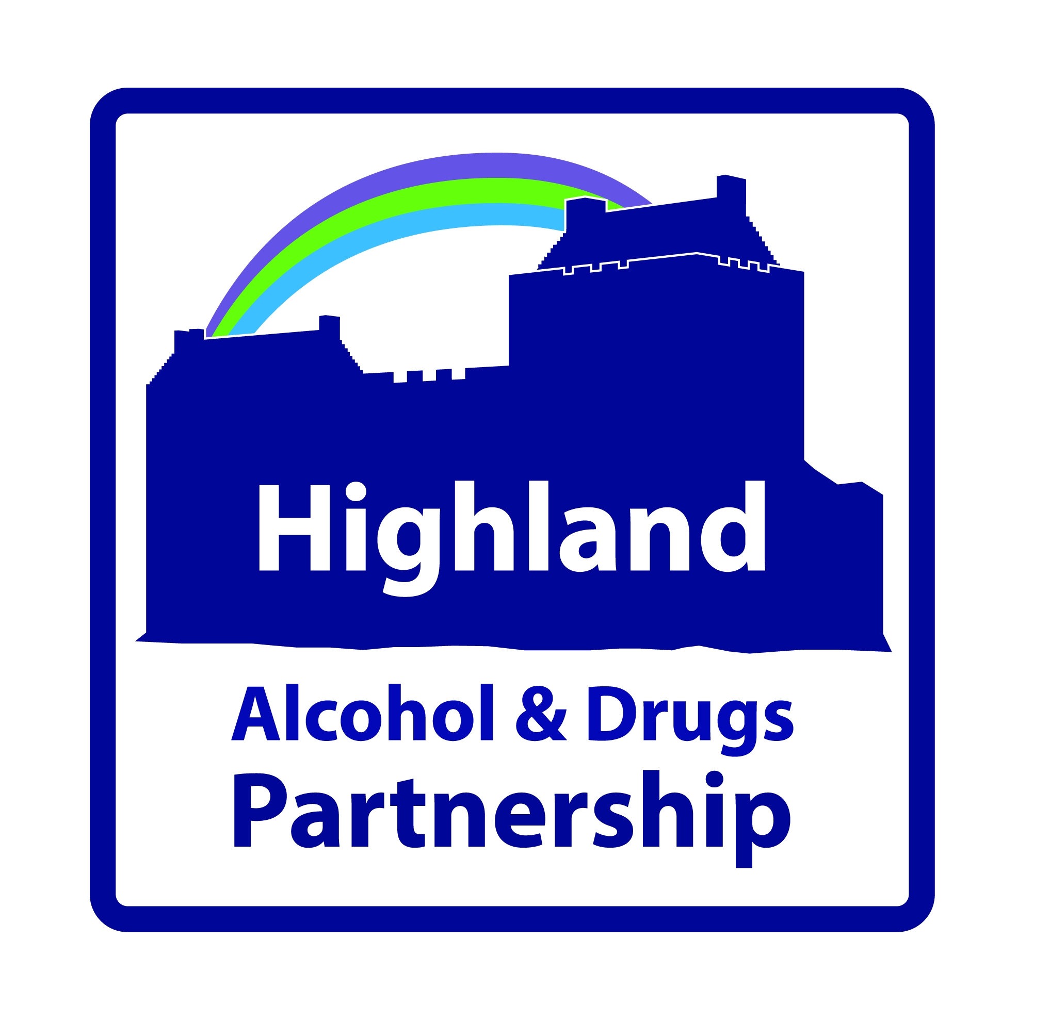
Highland Alcohol and Drugs Partnership (HADP)
Larch House, Stoneyfield Business Park, Inverness , IV2 7PA
15th August 2019
www.highland-adp.org.uk

Dear Sir / Madam,
Recovery Workers Training Project
Highland Alcohol and Drugs Partnership wish to invite organisations to provide applications to host and deliver a Highland Recovery Workers Training Project. The project will work in partnership to improve employability outcomes for people in recovery. The project will be funded from Scottish Government additional monies for alcohol and drugs.
The successful organisation (hereafter referred to as the Provider) will receive a funding award of (£25,000 from 1st Oct 2019 to 31st March 2020) and then (£49,999 from 1st April 2020 to 31st March 2021) that will be paid in 6 monthly instalments on evidence of outcomes. The project will be based and managed by an appropriate Third Sector agency. It will report to HADP and be supported and guided by a multi-agency advisory group made up of representatives from relevant partner agencies.
If you think your organisation is well placed and has the required skills, experience and capacity to deliver this project, please familiarise yourself with the Specification (Appendix 1) and complete the Application Form.
Your completed application and documents must be submitted no later than 25th September 2019. Final decisions on the allocation of the award will be made by a panel of experts representing HADP. Candidates may be invited to interview.
All enquiries and questions should be directed to deborah.stewart@nhs.net Tel: 01463 704608.
Yours sincerely,

Debbie Stewart
Coordinator

Appendix 1
Service Specification
Please read the contents of the specification very carefully and ensure that you complete the application in full. Applications which do not satisfactorily describe the practical means by which they will deliver the project/service will not be processed.

Background
Many people recovering from drug and alcohol problems live in poverty with limited opportunities to access meaningful, decently paid employment. This is likely to act as a barrier to moving on to fulfil their potential in the local community.
In the HADP area there are high rates of unemployment, insecure and low paid work among people in recovery. This is compounded by stigma and discriminatory attitudes and practices that act as a barrier to accessing and sustaining employment.
In addition, the remote and rural geography of Highland can result in difficulties filling posts, particularly in the health and social care sectors. Public and Third Sector services are some of the largest local employers and require replenishing their workforce continuously. It is therefore important to grow the local workforce and find innovative ways for employers to extend opportunities to people in Recovery.
The Highland Recovery Workers Training Project will build on the excellent work of current employability providers to increase provision, provide greater choice and extend opportunities for people in recovery. More specifically, the project will focus on strengthening employability routes in to health and social care opportunities. Providing people with very good quality certified training and work place opportunities for learning is essential. Whilst demonstrating the Fairer Scotland Duty is a key priority for the project. As well as increasing the visibility of recovery role models, the project is expected to contribute to tackling stigma and discrimination experienced by people with lived experience of drug and alcohol problems.

Outcomes
Reduced stigma, discrimination and inequality in employment
Increased range of options for accessing supported work experience
Increased employability routes to work in health/social care settings
Increased access to quality certified training and work place opportunities for learning
Increased visibility of recovery role models
Increased collaboration among employability providers to support people in Recovery
Increased delivery of peer education, service user involvement and peer led research
Increased knowledge and skills to influence employability initiatives
Increased range of employability opportunities available through Third and statutory sectors
Increased value accorded to the contribution PWLE can make to recovery orientated systems of care

Outputs
Supported route into employment in health and social care embedded
Recruitment and support of (up to 3 people in recovery / trainees per year)
Quality work placements in health and social care agencies
Certified training and vocational learning (e.g. SVQ’s)
Positive recovery role models for individuals, families and communities
PWLE / peer development initiatives
Peer related research
Involvement of PWLE in the evaluation, design and delivery of services

Service Activities

Recruit and support 3 Recovery Worker Trainees
Establish a drug and alcohol recovery orientated sustainable employability model
Provide opportunities and demonstrate best practice in developing routes in to employment that reduce the risk of relapse, poverty and isolation
Broaden the availability and range of employability options available
Demonstrate to health and social care employers effective routes for employing PWLE
Strengthen the role of peers and enhance capacity for research \ developmental skills
Facilitate a strong voice for PWLE to influence policy and service development
Scope proposals and additional resources to deliver long term system change

Governance and Accountability
The project will be managed and hosted in a Third Sector organisation. The project will be accountable, supported and guided by a multi-agency advisory group. Members of the advisory group will be experts in their field. The group will report to the HADP Strategy Group, who in turn is accountable to the Community Planning Partnership, the Integrated Authority and the Scottish Government.

Monitoring and Evaluation
To ensure Best Value in the provision of services in the most effective, efficient and economic manner; the successful organisation (referred to as Provider) will be required to enter in to a contract with HADP that will be regularly monitored. The contract will include the arrangements for monitoring and evaluation. The Provider will deliver quarterly progress reports and an annual report and presentation with evidence of how the funding has been spent and the outcomes achieved. The Provider will seek qualitative feedback from PWLE on their experience. The Provider will also agree to the sharing of any reasonable information requested by the HADP. HADP will provide a template to facilitate concise and meaningful feedback and contribute the skills of a Research and Intelligence Specialist to enable efficient monitoring and evaluation.

Professional Experience and Qualifications
It is expected that the successful organisation will have extensive experience, skills and expertise in both the drug and alcohol and employability areas of work. The organisation will have the systems and procedures in place to employ and support development of the project.

Partnership Working
All relevant partners will be committed to collaborating with the successful organisation to ensure the project is effectively supported and well placed to achieve the agreed outcomes.

Your completed application and documents must be submitted no later than 25th Sept 2019.
All enquiries and questions should be directed to deborah.stewart@nhs.net Tel: 01463 704608.

