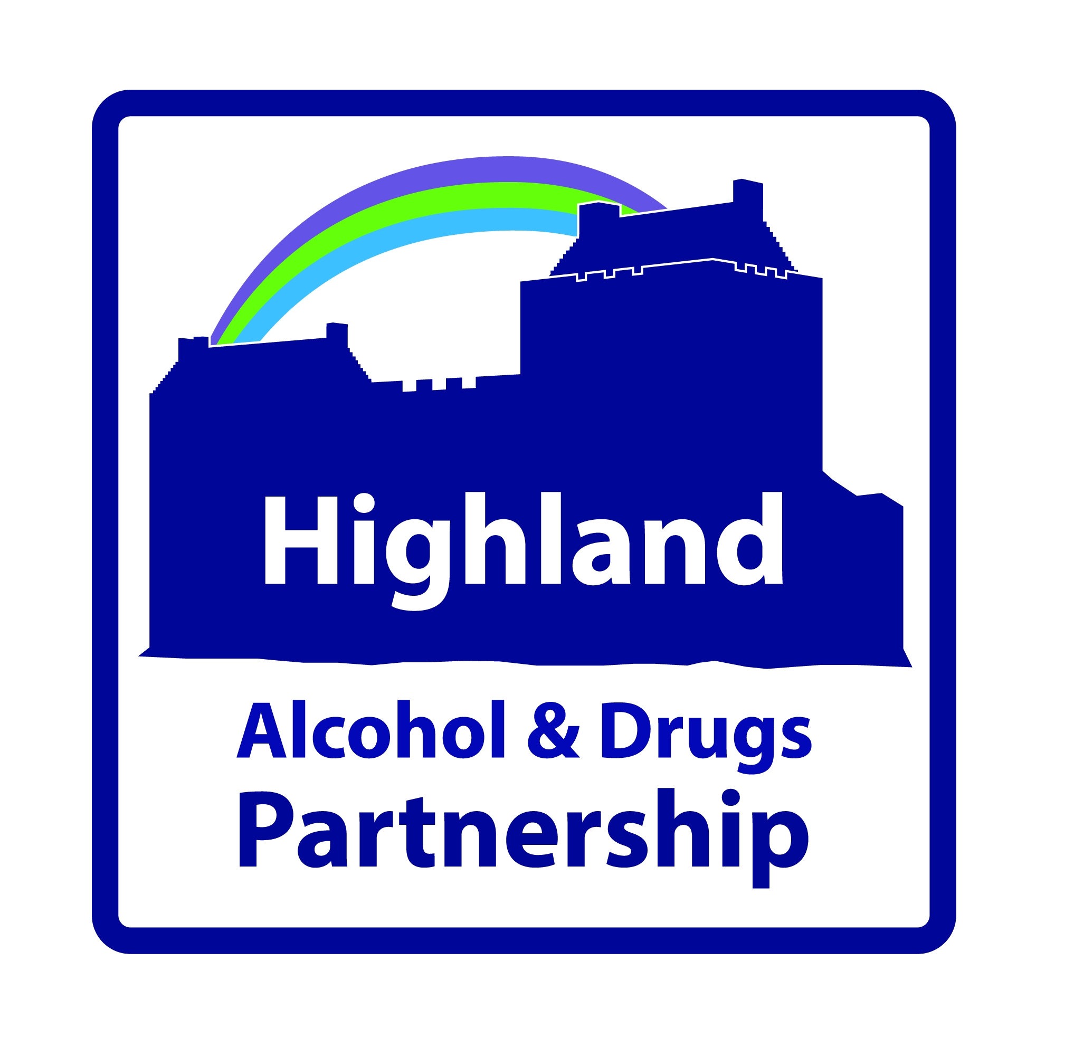
Alcohol & Drugs - Local Improvement Fund
Application Form
Section 1: Project and Lead Organisation Information
PROJECT INFORMATION
1.1 Name and address of Project:

1.2 Name and address of lead organisation:

1.3 How will the project be managed?

1. 4 Is the project part of a consortium bid?  If yes please name partners below |  | Yes
 |  | No
Name of Organisation | Role within the Project

CONTACT INFORMATION FOR PROJECT LEAD ORGANISATION
1.5 Contact Name:
1.6 Contact Telephone:
1.7 Contact Email:
1.8 Contact’s Position in Organisation:
LEAD ORGANISATION
1.9 Is your organisation a registered charity? | Yes  No
1.10 If yes, what is the charity number?
1.11 What is the status of your organisation if it is not a charity?
1.12 Please attach your last years audited accounts and provide a brief overview of the lead organisation.
Note: For the lead organisation this should include:
- aims and objectives of your organisation;
- brief description of your organisation such as structure, accountability,
board and
management;
- length of time established;
- brief summary of your record of delivery, key success and dates.

Section 2: The Application
The Funding request below is sought from the HADP Local Improvement Fund as part of investment in preventing and reducing drug and alcohol related harm and supporting recovery.
PRIORITIES
2.1 Please detail which priorities align with the project
(See FAQ’s No 5)

FUNDING
2.2 How much will the project cost?
2.3 How much funding are you applying for?
Note: If your organisation is successful in obtaining funding, it will be paid in 2 x 6 monthly instalments on evidence of outcomes. In the event that outcomes are not achieved or the funding is not used for the purposes intended, it will be returned to HADP.

Please provide details of other funding provided or applied for to support this project.
Other Funding Requested/provided for this Project
2.4 Amount of funding provided from other sources:
2.5 Name of other sources applied to or providing funding:

2.6 What will the funding be used for?
2.7 Who is your intended target group?

2.8 What are the 3 most important improvements or outcomes that this funding will achieve for the target group?

2.9 Please list and quantify the activities or services you will deliver to help you achieve the outcomes? (These are referred to as your outputs)

2.10 How will you know you are achieving the outcomes and making a difference to the target group (e.g. what data, information or feedback will you collect / record)

2.11 How will this project contribute to delivering the national strategy (Rights, Respect & Recovery) and the HADP Strategy?

2.12 How was the need for this project identified? (What evidence is there? How have you established demand for the project?)

2.13 What learning outcomes are envisaged at the end of this project that will bring a Highland wide benefit?

2.14 If this project is successful how will you sustain it in the long term? (What are the plans for funding when this award ends?)

2.15 Please provide a brief timeline for the project. (Preferably to March 2021)

2.16 What potential barriers will you face and how will you overcome these?
Challenge/Risk | Mitigating Action
1. | 1.
2. | 2.

2.17 Please describe your exit strategy from this project.

SECTION 3: DECLARATION
I apply on behalf of the organisation named above for funding as proposed in this application in respect of expenditure to be incurred over the proposed funding period on the activities described above.
I certify that, to the best of my knowledge and belief, the statements made by me in this application are true and the information provided is correct.
If this application is successful; I agree on behalf of my organisation that we will attend and participate relevant HADP activities e.g. annual stakeholder conference.

Signature:

Name:

Position:

Date:

Notes on making an application

How to complete your application form
General
- Please complete and return the form electronically. Please note the fields are expandable.
- Please answer each question on the application form as concisely as possible in a bullet point format where appropriate.

Section 1: | Project and Lead Organisation Information

This section tells us about the lead organisation, contact information, the location of the Project.

The contact for your application should be someone who is able to discuss the work of the Project and the application in detail.

Section 2: | The Application

This allows you to tell us information about the project, which includes; the funding amount requested; intended target group(s); expected outcomes/improvements; how the project aligns with national and local strategies and learning outcomes.

The aim is to provide funding to partner agencies, including the Third Sector to support implementation of the Highland Alcohol and Drugs Strategy and the national strategy; Rights, Respect and Recovery. The key purpose is to resource activities and service developments that help to prevent and reduce alcohol and drug related harm and support recovery. Please note the funding cannot be used to support core / existing activities.

The funding is to be used to provide opportunities to:

- Test new approaches
- Improve ways of working
- Support Recovery

Funding is available from the HADP Local Improvement Fund for this one occasion only. Please ensure your application is fully completed and details in full the funding requested.

Section 2.4: Please also detail here if you have made a bid for other funding sources and have not yet received a reply.

Section 2.6: Please describe what the funding will be spent on.
Section 2.7: Please detail the main target group (e.g. young people, people in recovery, families, older people etc), but also other groups that this may benefit, such as families, local communities.

Section 2.8 to 2.10: Please detail the expected outcomes and outputs and say how these will be measured. This will in turn link into the short evaluation report which is required at the end of the year (by 30 March 2021).

Section 2.11: Please describe concisely how the project aligns to the national and local alcohol and drugs strategy.
Section 2.12: Please describe the circumstances leading up to this project. You should refer to any studies, research, feedback, community consultation or service user involvement that has aided identification of your project.
Section 2.13: Please include possible plans for embedding learning within your organisation and sharing learning / improving practice across Highland.
Section 2.16: Please indicate the major risks to your project and how you will mitigate their impact.
Section 2.17: Please detail your plans to manage demand and expectations from the target groups if your project is unsuccessful.
Section 3: | Declaration

Please ensure this section is fully completed.

You should ensure you attach a summary of the previous years audited accounts for the lead organisation.

