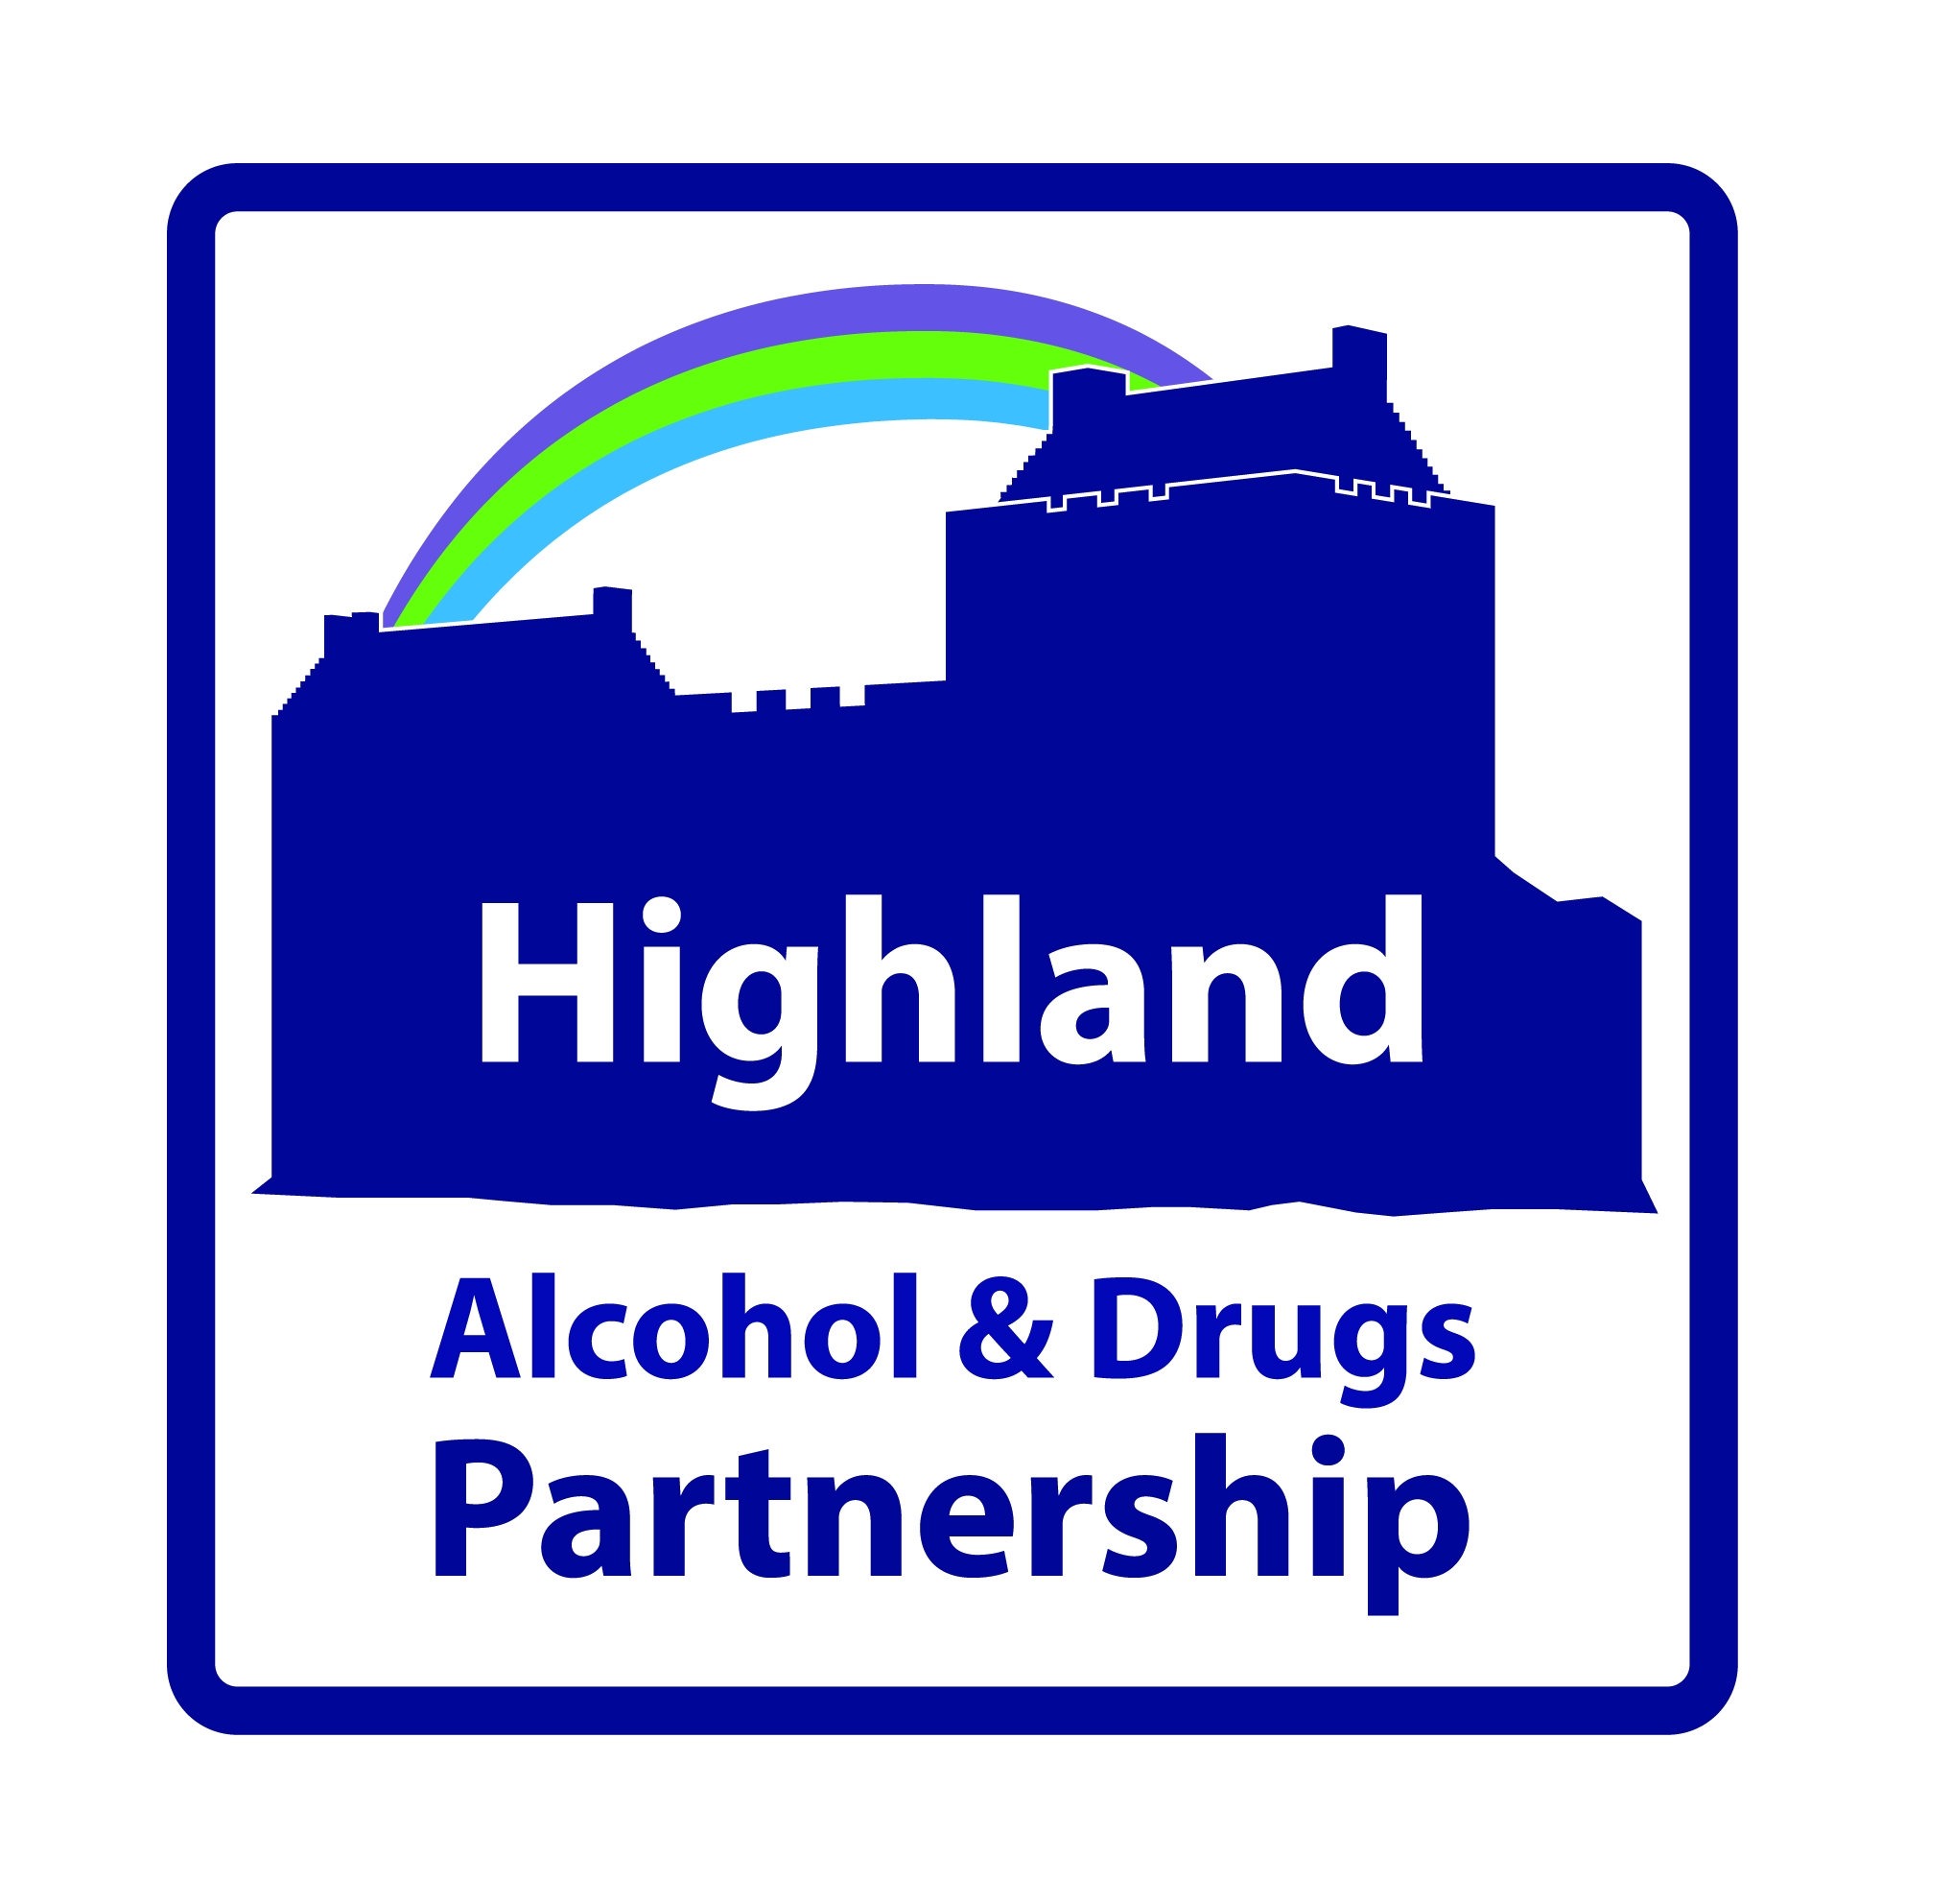
Highland Alcohol & Drugs Partnership
Area Improvement Fund
Application Form
Please read the “Notes on Making an Application” (page 9) carefully before completing this form.
Concise answers are requested. Where appropriate, a maximum word count for each question is shown in brackets and should not be exceeded. Shorter answers can be provided.
All questions should be completed in full. No supplementary attachments/embedded documents allowed, unless expressly asked for.
Please note that it is not acceptable to repeat the information in the Project Brief. A clear and considered plan of the work that will be undertaken to achieve the outcomes is what is requested from the application.
Please ensure that you answer all the questions.
All personal information supplied will be treated as confidential and will be subject to the General Data Protection Regulation and Data Protection Act 2018.

Section 1: CONTACT & ORGANISATIONAL INFORMATION
CONTACT INFORMATION
1.1 Name of organisation:

1.2 Charity Number, date constituted, Company Number (or describe other status)
1.3 Full address, telephone number and website of organisation:

1.4 Name, email, position and telephone number of main contact:
1. 5 Is the project part of a consortium bid?  If yes please name partners below |  | Yes
 |  | No
Name of Organisation | Role within the Project

ORGANISATIONAL INFORMATION
1.6 Please attach your last years audited accounts and provide a brief overview of the organisation (300 words).
Note: This should include: the purpose,
aims and objectives of your organisation;
- range of services you provide
-what the organisation does on a daily basis
- brief description of your organisation structure, accountability,
board and
management;
- length of time established;
- brief summary of your record of delivery, key success and dates.
1.7 Explain in what way your organisation is well placed to meet the needs of the target group and the challenges they face. (300 Words)
- evidence how you know there is a need for this type of service
- describe the challenges the target group experience
- describe the skills and experience that you have in your organisation to tackle these challenges

Section 2: The Application
The Funding request below is sought from the HADP Highland Area Improvement Fund as part of investment in preventing and reducing drug and alcohol related harm and supporting recovery.
FUNDING
2.1 How much will the project cost?
2.2 How much total funding are you applying for? (Until March 2020)

BUDGET PLAN
2.3 What is your budget plan?
Item/ Activity | 2019/2020  (01/10/19 – 31/03/2020) | 2020/2021  01/04/2020 – 31/03/2021
Note: If your organisation is successful in obtaining funding, it will be paid in 6 monthly instalments on evidence of outcomes. In the event that outcomes are not achieved or the funding is not used for the purposes intended, it will be returned to HADP.

Please provide details of other funding provided or applied for to support this work.
Other Funding Requested/provided for this type of Project
2.4 Amount of funding provided from other sources:
2.5 Name of other sources applied to or providing funding:

2.6 What will the funding be used for? (300 words). Describe the work you are asking us to fund. This should include; the type of service, who will deliver it (existing/new staff), what will they actually do, how will the work be managed, who will be the key partners and what contribution will they make.

2.7 How will you proactively engage people with lived experience and involve them in the development of the project? (200 words).

2.8 What are the 3 most important improvements or outcomes that this funding will achieve for the target group?

2.9 Please list and quantify the activities/tasks you will deliver to achieve the outcomes? What will the outputs be

2.10 How will you know you are achieving the outcomes and making a difference to the target group? (e.g. what data, information or feedback will you collect / record.

2.11 How will this project contribute to delivering the national strategy (Rights, Respect & Recovery) and the HADP Strategy?

2.12 How was the need for this project identified? (What evidence is there? How have you established demand for the project?)

2.13 What learning outcomes are envisaged at the end of this project that will bring a Highland wide benefit?

2.14 If this project is successful how will you sustain it in the long term? (What are the plans for funding when this award ends?)

2.15 Please provide a brief timeline for the project. (To March 2020)

2.16 What potential barriers will you face and how will you overcome these?
Challenge/Risk | Mitigating Action
1. | 1.
2. | 2.

2.17 How will you monitor and evaluate the work and use this information to improve practice What measures will be used, how will you use the findings to improve practice. (If you need assistance with how you respond to this question, please ask HADP).

2.18 Please describe your exit strategy from this project.

SECTION 3: POLICIES AND INSURANCES
Please confirm your organisation has up-to-date safeguarding policies. ☐
Please tick to confirm that PVG checks are carried out on all staff and volunteers working with children, young people and vulnerable adults. ☐

If the service you are asking us to fund could incur employee and/or public liability please confirm that you already have or can commit to obtaining prior to commencement of the funding award, the following levels of insurance cover:
 | Employers (Compulsory) Liability Insurance  (£5m minimum cover) | Public Liability Insurance  (£5m minimum cover)
Yes, I already have this
No, but I commit to obtain it
No, and I cannot commit to obtain it
Not applicable

Please ensure you include the following with this form:
A copy of your last annual accounts/financial statement. ☐
SECTION 4: DECLARATION
I apply on behalf of the organisation named above for funding as proposed in this application in respect of expenditure to be incurred over the proposed funding period on the activities described above.
I certify that, to the best of my knowledge and belief, the statements made by me in this application are true and the information provided is correct.
Knowingly providing false information will invalidate any application.
If this application is successful; I agree on behalf of my organisation that we will attend and participate in relevant HADP activities e.g. annual stakeholder conference.
Signature:

Name:

Position:

Date:

Please email your completed application to aileen.trappitt@nhs.net no later than noon on 25th September May 2019. Applications received after this time will not be accepted.

Notes on Making an application

How to complete your application form
General
- Please complete and return the form electronically. Please note the fields are expandable.
- Please answer each question on the application form as concisely as possible in a bullet point format where appropriate.

Section 1: | Contact and Organisation Information

This section tells us about the organisation, contact information and charitable status.

The contact for your application should be someone who is able to discuss the work of the Project and the application in detail.

Section 2: | The Application

This allows you to tell us information about your organisation, which includes; the funding amount requested; experience with the intended target group(s); how you plan to deliver the expected outcomes/improvements; how your organisation will deliver the project in alignment with national and local strategies and how you will ensure learning outcomes are shared so as to improve policy and practice development.

The aim is to provide funding to a Third Sector partner to support implementation of the Highland Alcohol and Drugs Strategy and the national strategy; Rights, Respect and Recovery. The key purpose is to resource activities and service developments that help to prevent and reduce alcohol and drug related harm and support individual and family recovery. Please note the funding cannot be used to support core / existing activities.

The funding is to be used to provide opportunities to:

- Test new approaches
- Improve ways of working
- Support Recovery

Funding is available from the HADP Highland Area Improvement Fund for this one occasion only. Please ensure your application is fully completed and details in full the funding requested.

Section 2.4: Please also detail here if you have made a bid for other funding sources and have not yet received a reply.

Section 2.6: Please describe what the funding will be spent on.
Section 2.7: Please detail approaches you will use to reach out and sustain engagement with people with lived experience, particularly people disadvantage through poverty.

Section 2.8 to 2.10: Please detail the most important outcomes or improvements in people’s lives. Describe what you will actually do to deliver on the main outputs and say what indicators will be measured. This will in turn link into the short evaluation report which is required at the end of the year (by 30 March 2020).

Section 2.11: Please describe concisely how the project aligns to the national and local alcohol and drugs strategy.
Section 2.12: You should refer to any of your own work or studies, research, feedback, community consultation or service user involvement that has aided identification of the need for this project.
Section 2.13: Please include possible plans for embedding learning within your organisation and sharing learning / improving practice across Highland.
Section 2.16: Please indicate the major risks to your project and how you will mitigate their impact.
Section 2.17: Please detail your plans to manage demand and expectations from the target groups if your project is unsuccessful.
Section 3: | Policies and Insurances

Please ensure this section is fully completed.

You should ensure you attach a summary of the previous years audited accounts for your organisation.

Section 4: | Declaration

Please ensure this section is fully completed and signed.

You should ensure you attach a summary of the previous years audited accounts for the lead organisation.

