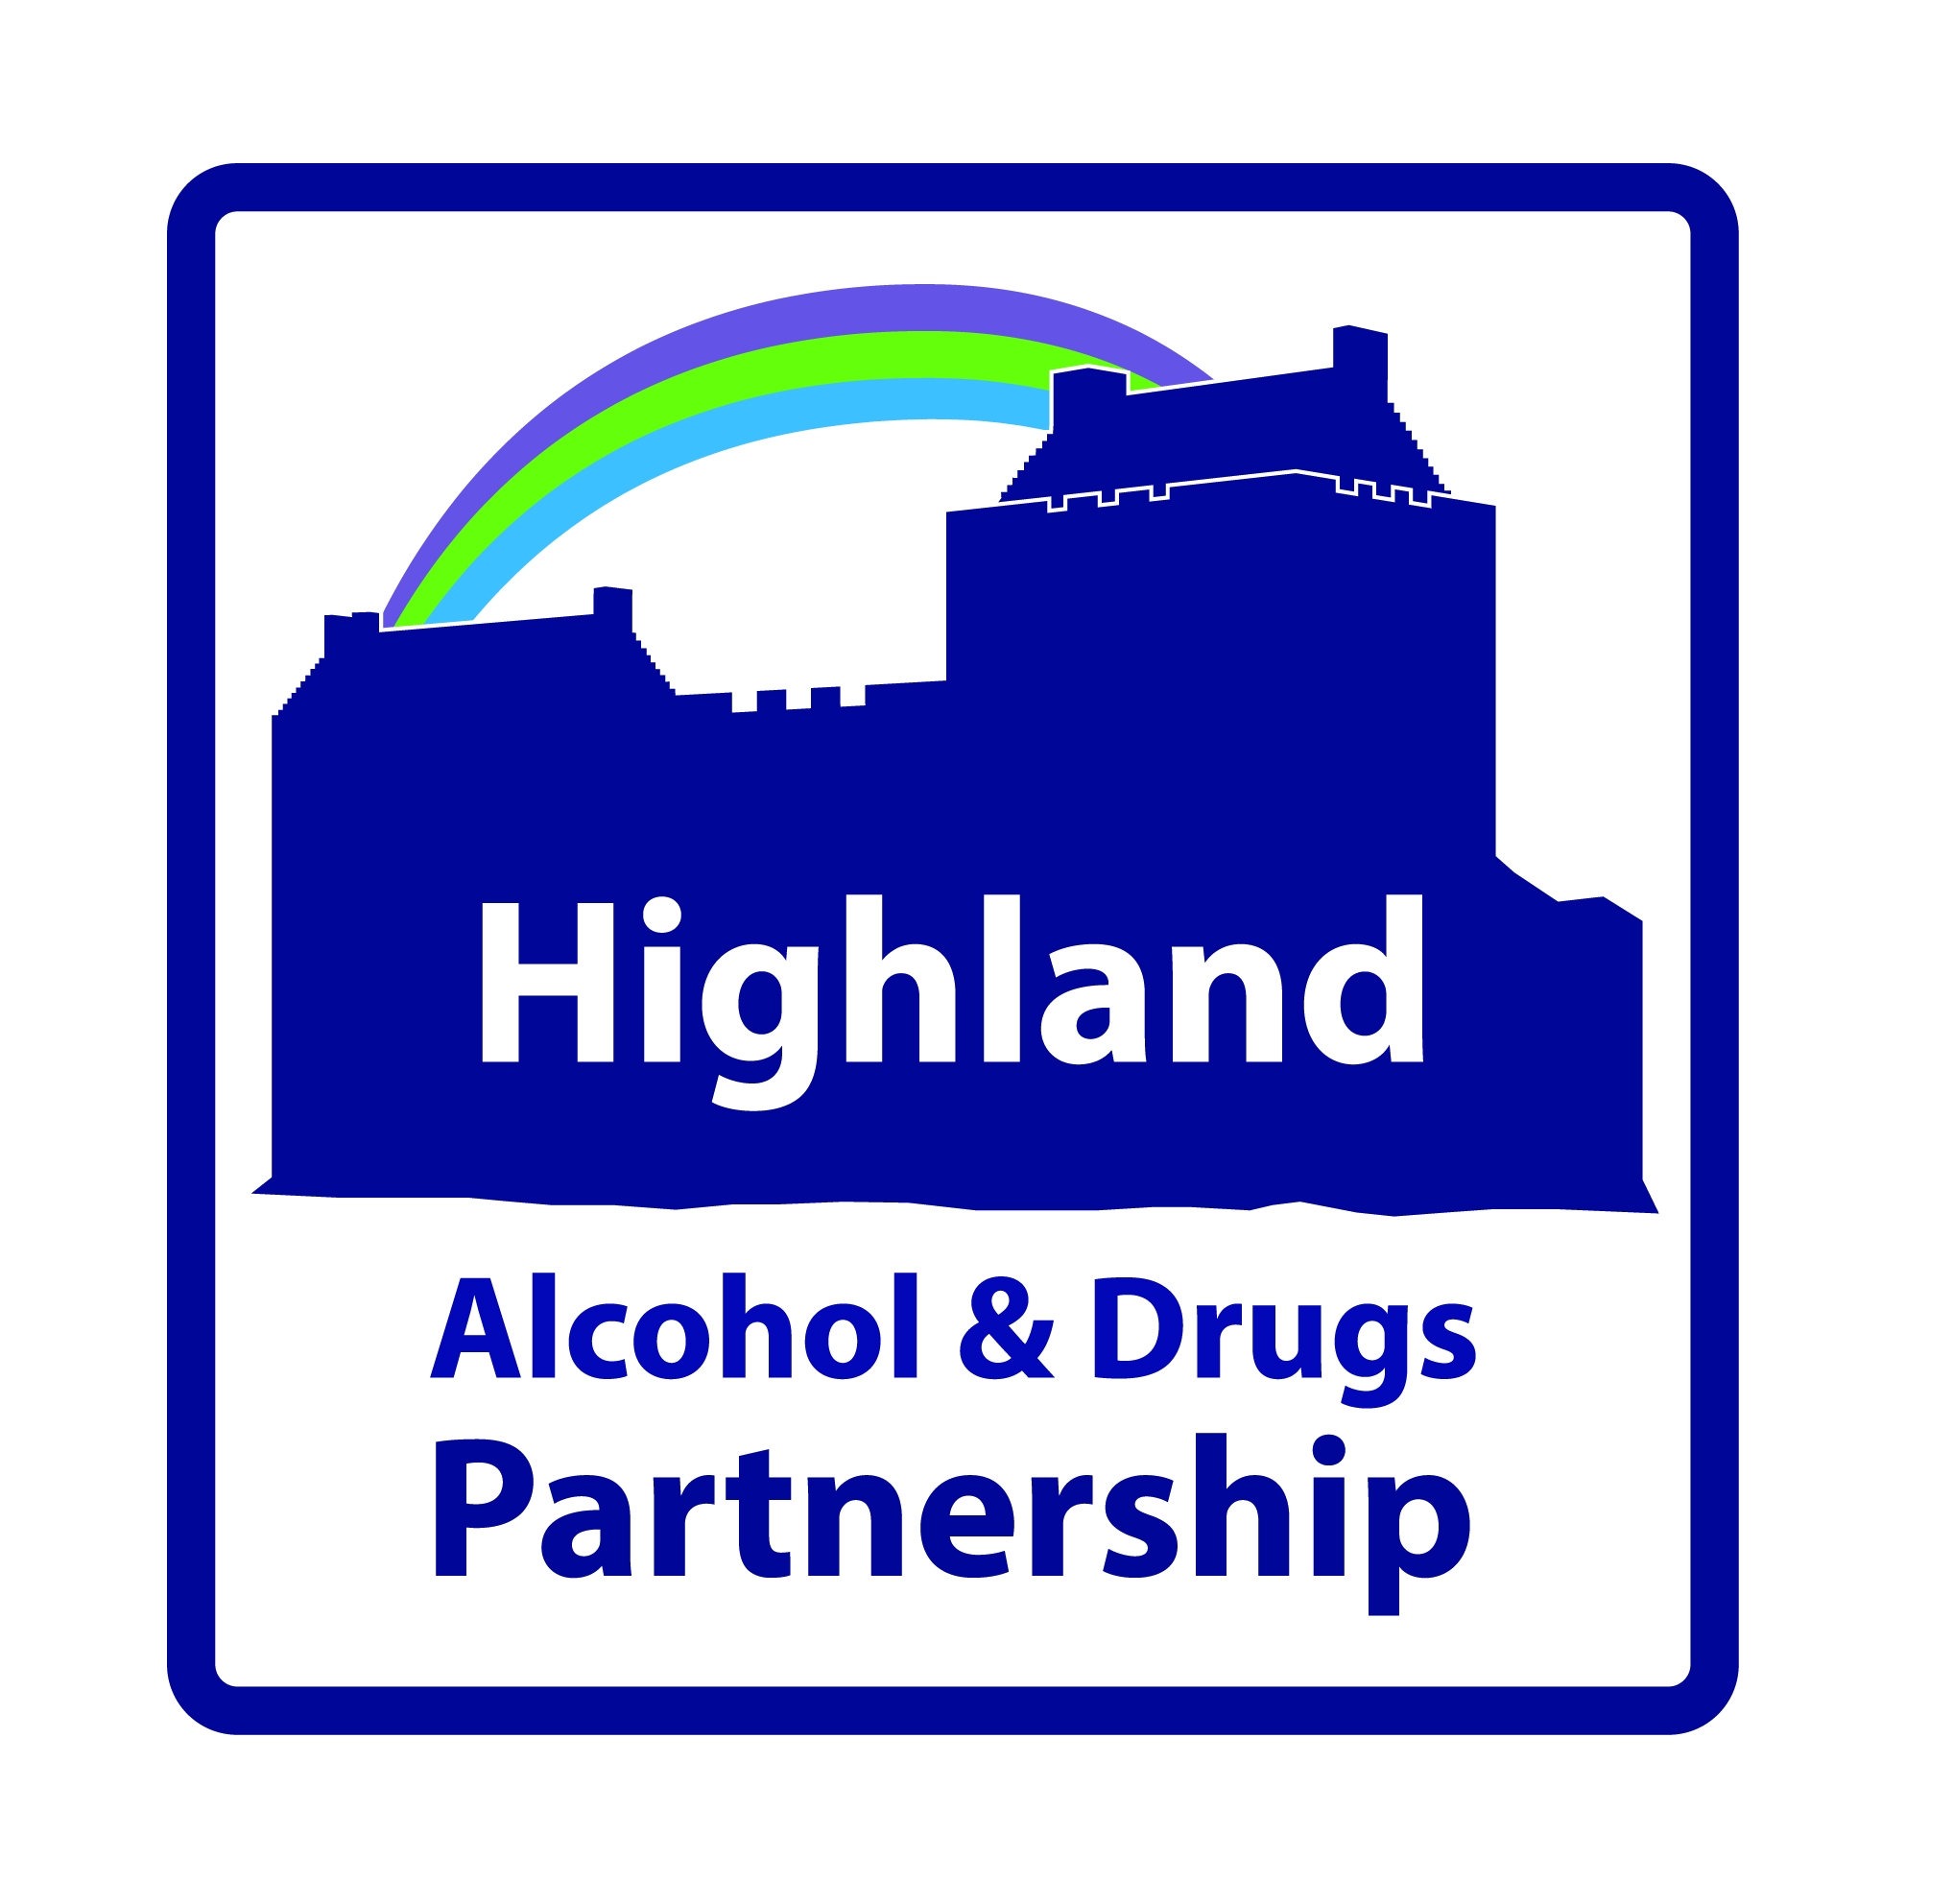
Highland Alcohol and Drugs Partnership (HADP)
Larch House, Stoneyfield Business Park, Inverness, IV2 7PA
15th August 2019
www.highland-adp.org.uk

Dear Sir / Madam,
Coordinator - Children and Families Affected by Problem Drug and Alcohol Use
Highland Alcohol and Drugs Partnership (HADP) in collaboration with Highland Child Protection Committee (HCPC) wish to invite organisations to provide applications to host and deliver a multi-agency Coordinator post. The post will work across Adult and Children’s Services to improve outcomes for Children and Families Affected by Problem Drug and Alcohol Use. The post will be funded from Scottish Government additional monies for alcohol and drugs.
The successful organisation (hereafter referred to as the Provider) will receive a funding award of (£25,000 from 1st Oct 2019 to 31st March 2020) and then (£49,999 from 1st April 2020 to 31st March 2021) that will be paid in 6 monthly instalments on evidence of outcomes. The post will be based and managed by an appropriate Third Sector agency. It will report and be supported and guided by a multi-agency steering group made up of representatives from relevant partner agencies.
If you think your organisation is well placed and has the required skills, experience and capacity to deliver this project, please familiarise yourself with the Specification (Appendix 1) and complete the Application Form.
Your completed application and documents must be submitted no later than 25th September 2019. Final decisions on the allocation of the award will be made by a panel of experts representing HADP. Candidates may be invited to interview.
All enquiries and questions should be directed to deborah.stewart@nhs.net Tel: 01463 704608.
Yours sincerely,

Debbie Stewart
Coordinator
Appendix 1 - Project Brief
Please read the contents of the Project Brief very carefully and ensure that you complete the application in full. Applications which do not satisfactorily describe how they will deliver the project/service will not be processed.

Background
There are substantial numbers of children and young people in Highland affected by parental problem drug and alcohol use, with many hidden from services due to stigma and fear of removal.

Parental problem drug and/or alcohol use is a concern in a significant number of child protection cases.

Although much progress has been made, there is a need to further improve interagency communication and integrated practice, particularly across Adult and Children’s Services.

There is a need to embed whole family approaches to recovery to improve outcomes for children, young people, adults and families.

Vulnerable young people, including children affected by parental problem drug or alcohol use are at higher risk of developing a range of problems in adulthood.

Vulnerability can increase the risk of substance use, mental health problems, adverse childhood experiences, being looked after and accommodated, offending and experiencing difficulties transitioning to adulthood.

Improved integrated practice with clear pathways and standard operating procedures require to be formalised, and visible to families and practitioners in order to improve outcomes.
Outcomes
Increased holistic/seamless/family-centred experience of support
Improved integrated pathways supporting whole families in the recovery process
Increased engagement of vulnerable families with both adult and children’s services
Increased nos. of families supported to manage complex needs
Increased parental/carer awareness of potential impact of problem substance use on child development
Increased trauma informed practice to respond effectively to ACE’s
Increased voice of children and young people in the recovery process
Improved child safety/security and stronger family relationships
Increased participation of vulnerable families in positive activities
Improved support for children affected by overdose and parental death
Improved support for parents when children are removed
Improved integrated support to higher risk young people to address substance use,offending, leaving care, transitions to adulthood

Outputs
Interagency practice audit
Effective interagency communication
Seamless interagency practice
Embed whole family approaches
Whole family workforce development and resources
Clear visible interagency pathways/protocols/ standard operating procedures
Embed ACE aware/trauma-informed practice
Evidence-informed early intervention for children and families
Evidence-informed early intervention for higher risk young people using substances
Clear transition routes from children to adult services
Interagency support for complex needs (parental death/child removal)
Child/young people involvement in policy/service development
Embed outcomes tools (e.g. Outcomes/Family Star / Starting a Conversation, Recovery Outcomes Tool)

Service Activities
HADP, CPC, NHS Highland, Highland Council and the Third Sector via the Coordinator post will work in partnership to:

Establish integrated and trauma informed children/young people’s services with robust inter-agency pathways that effectively address; substance use, ACE’s, mental health, offending, leaving care, transitions to adulthood
Embed clear interagency pathways/protocols/standard operating procedures to support integrated practice (adult & children’s services) and whole family support/recovery
Strengthen joint resources / workforce development / to improve inter-agency working
Develop innovative approaches to delivery of treatment and support to whole families
Explore approaches for including vulnerable families in Housing First and other intensive support initiatives
Increase participation of vulnerable children and families in positive activities
Develop trauma-informed psychosocial interventions for delivery in whole family settings
Pilot use of Outcomes Tools (e.g. Outcomes Star, Starting a Conversation)
Increase uptake and develop the CAPSM Toolkit for use across services
Strengthen support to enable vulnerable families to remain together or prepare for removal
Clarify support needs for parents to reduce risk of overdose/drug or alcohol related death
Clarify support needs for children bereaved through parental drug/alcohol death
Develop approaches that give a voice to vulnerable children/young people and families
Administer a family fund to support practice and service developments
Scope proposals and additional resources to deliver long term system change

Governance and Accountability
The Coordinator post will be managed and located in a Third Sector organisation. The project will be accountable, supported and guided by a multi-agency steering group. Members of the steering group will be experts in their field. The Steering Group will report to the HADP Strategy Group and Highland Child Protection Committee, who in turn are accountable to the Community Planning Partnership, the Integrated Authority and the Scottish Government.

Monitoring and Evaluation
To ensure Best Value in the provision of services in the most effective, efficient and economic manner; the successful organisation will be required to enter in to a contract with HADP that will be regularly monitored. The contract will include the arrangements for monitoring and evaluation. The Provider will supply quarterly progress reports and an annual report and presentation with evidence of how the funding has been spent and the outcomes achieved. The Provider will seek qualitative feedback from children, young people and families on their experience of services. The Provider will also agree to provide any reasonable information requested by the HADP or HCPC. HADP will provide a template to facilitate concise and meaningful feedback and contribute the skills of a Research and Intelligence Specialist to enable efficient monitoring and evaluation.

Professional Experience and Qualifications
It is expected that the successful organisation will have extensive experience, skills and expertise in both the children and families and drug and alcohol areas of work. The organisation will have the systems and procedures in place to employ, support and develop the post holder who is likely to be professionally qualified in social work and/or nursing.

Partnership Working
All relevant partners will be committed to collaborating with the successful organisation and the post holder to ensure the project is effectively supported and well placed to achieve the agreed outcomes.

Your completed application and documents must be submitted no later than noon on 25th September 2019.
All enquiries and questions should be directed to deborah.stewart@nhs.net Tel: 01463 704608.

