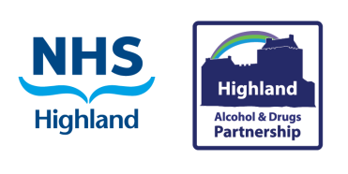
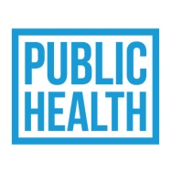
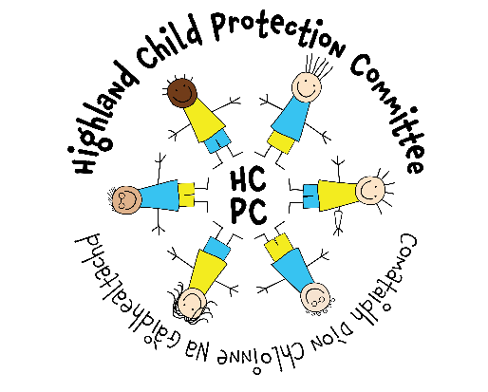
Alcohol Information Signposting

In challenging times, sometimes, people turn to alcohol for stressful relief. However, we know that alcohol is not an effective stress relief, and can makes things worse.
Sometimes adults might not realise the impact alcohol has on children, young people or other adults in the home.
If you are an adult, and choose to drink alcohol, remember to try and keep to the low-risk recommendations: More information at the Count 14 website.
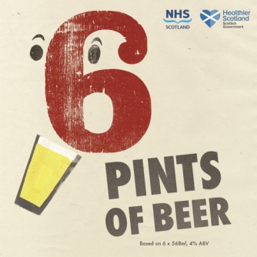 or 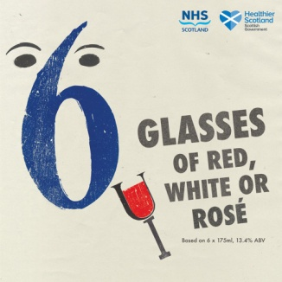 or 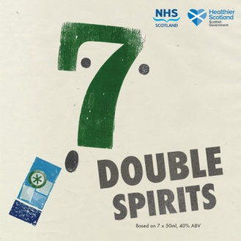
The following websites and phone support resources can be really helpful for families to get good quality information and support about alcohol:
- Alcohol Change UK is a leading UK alcohol charity. Includes links like:
  - I think my parents drink too much
  - Parents who drink too much
- Scottish Families Affected by Alcohol and Drugs supports anyone who is concerned about someone else's alcohol or drug use.
- A.D.A.M Another’s drinking affects me A web site for young people who are concerned or affected by another person's drinking
- Know the Score Scotland’s Drugs Information Gateway
- Crew a harm reduction charity based in Scotland
- Highland Substance Awareness Toolkit online resource for young people, parents and carers, and professionals
- Highland Alcohol and Drugs Partnership information relating to the Highland area, with signposts for getting help, local information, and other useful links
- Children’s Parliament investigates: an alcohol-free childhood – Video
- Drinkline. The national alcohol helpline. If you're worried about your own or someone else's drinking, you can call this free helpline in complete confidence. Call 0300 123 1110 (weekdays 9am to 8pm, weekends 11am to 4pm).
- Drug and Alcohol Board Game developed by young people for young people, with support from Action for Children.
- Childline Alcohol page or call 0800 1111

