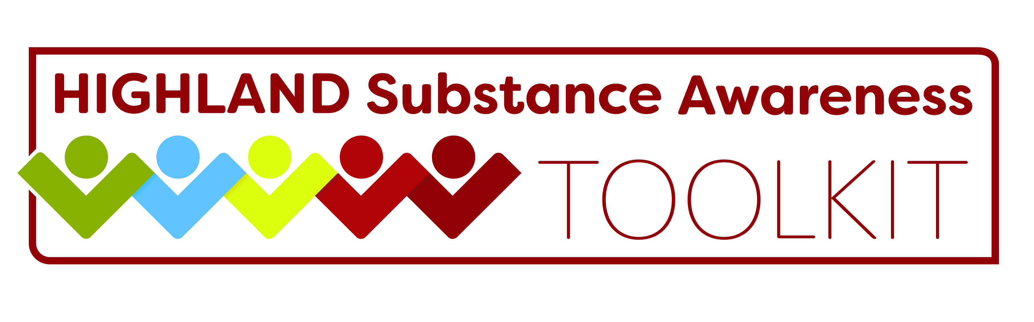

Preventing Substance Use Among Children and Young People
Empowering children and young people through prevention and education in school and beyond

Thursday 21st June 2018 1 - 4.30pm
Culloden and Balloch Baptist Church, Inverness
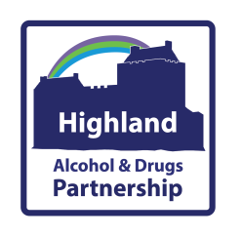
This interactive event will include speakers from the Highland Alcohol and Drugs Partnership Strategy Group

There will be a series of workshops:
- The Highland Substance Awareness Toolkit – What’s New
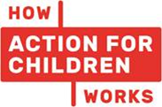
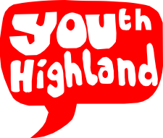
- Lesson Plan Showcase
- By Young People, For Young People
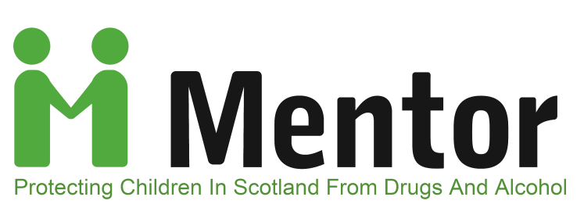
We’re pleased to welcome Mentor Scotland who will be sharing What Works in Prevention and Education

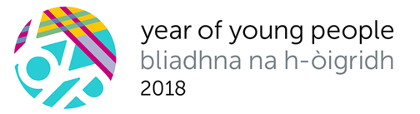
Another new development to support education and prevention in the Highlands will be launched on the day!

