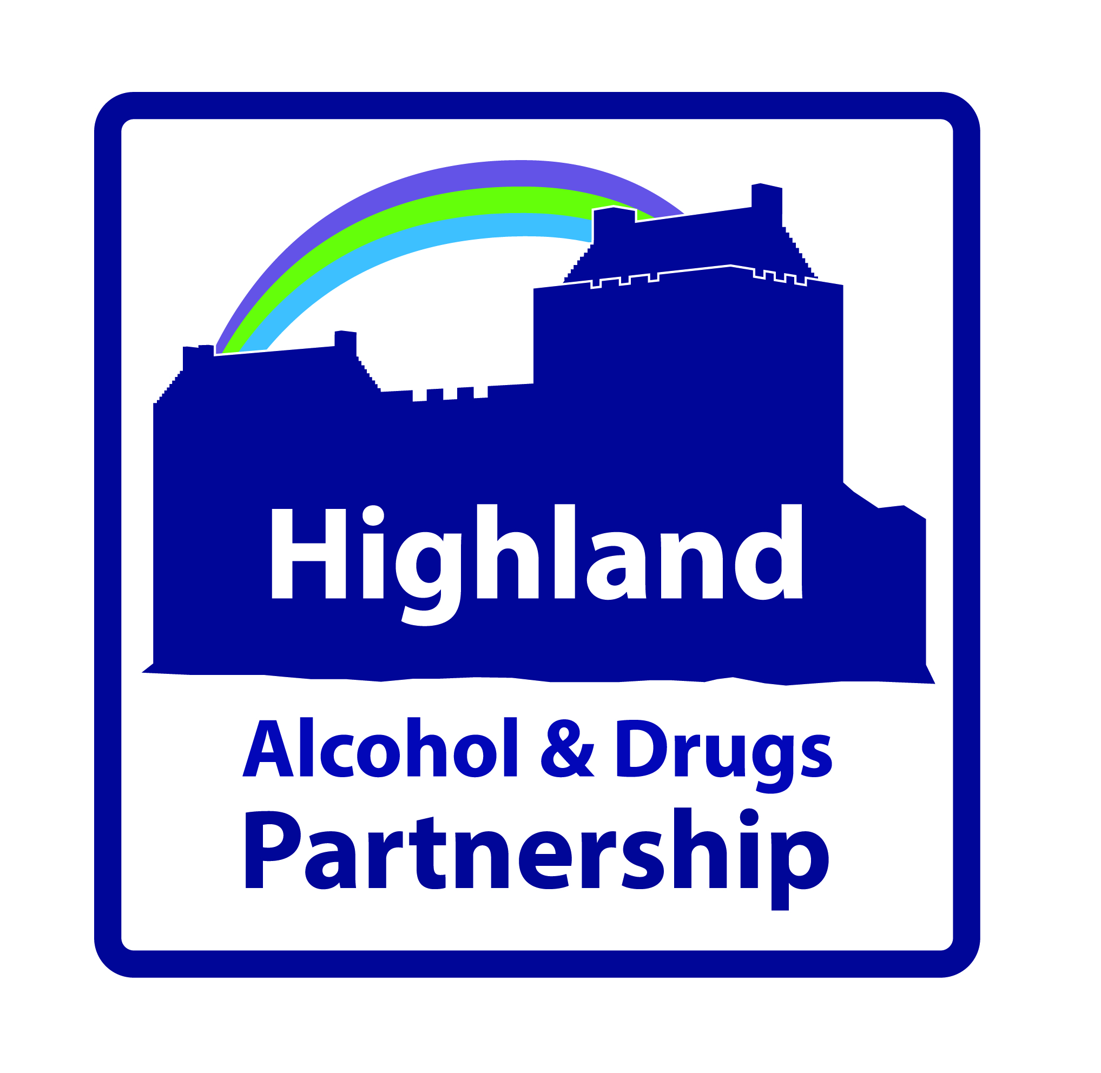

HIGHLAND ALCOHOL AND DRUGS PARTNERSHIP (HADP)
Rights, Respect and Recovery
Tuesday 18th June 2019 10am – 3.45pm
Centre for Health Science, Raigmore, Inverness

REGISTRATION FORM

Name:

Job title:

Organisation:
Address:

Tel Contact: |  | Email:

Morning Workshops - Every effort will be made to ensure you are booked on to your first choice, however please select a second choice in case this is not possible.

Workshop 1 – Strengthening Communities Lochaber Hope
Workshop 2 – Quality Improvement in a Recovery Service Drug and Alcohol Recovery Service
Workshop 3 – Young Peoples Involvement in Serious Organised Crime Action for Children
Workshop 4 – Icelandic Prevention Model Highland Alcohol and Drugs Partnership
Workshop 5 – Trauma Informed Approaches Public Health, NHS Highland

1st Choice:

2nd Choice:

Afternoon Workshops - Every effort will be made to ensure you are booked on to your first choice, however please select a second choice in case this is not possible.

Workshop 6 – Strengthening Communities Lochaber Hope
Workshop 7 – Quality Improvement in a Recovery Service Drug and Alcohol Recovery Service
Workshop 8 – Young Peoples Involvement in Serious Organised Crime Action for Children
Workshop 9 – Icelandic Prevention Model Highland Alcohol and Drugs Partnership
Workshop 10 –Trauma Informed Approaches Public Health, NHS Highland

1st Choice:

2nd Choice:

Please advise if you have any special requirements (including dietary/access):

Please return your completed form to:
Aileen Trappitt, Administrative Officer, Highland ADP, Larch House, Stoneyfield Business Park, Inverness IV2 7PA Tel 01463 704603 / email aileen.trappitt@nhs.net
by Tuesday 10th June 2019

