**Dr John Budd, NHS Lothian**

John has been working as a GP with the Access Practice since 2006. The Access Practice are a GP Practice providing a range of health care services for homeless patients, in partnership with social work and housing colleagues. Previously John worked as a GP specialist in substance misuse in Muirhouse, Edinburgh. He has also worked as a community doctor in rural Kwazulu-Natal, South Africa, having, previously completed an MSc in African studies. John is the co-ordinator of Deprivation Interest Group, which is a Lothian group of health care workers – mainly GOs. Their aim is to promote high quality primary care for socially excluded groups and communities experiencing high levels of multiple deprivation, with a view to reducing health inequalities. John is also a steering group member for the Deep End project, chair of the board of trustees for North Edinburgh Drug and Alcohol Centre (NEDAC) and on the board for Scottish Drugs Forum

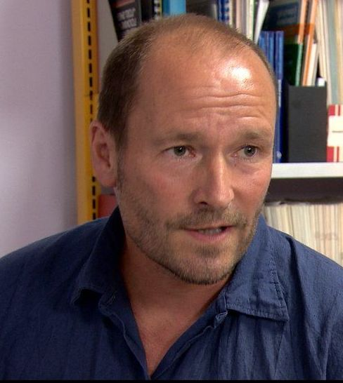

### **David Liddell OBE**

##### **Chief Executive Officer, Scottish Drugs Forum**

David leads the SDF staff team and reports directly to SDF’s Board of Directors. He has worked for Scottish Drugs Forum since its inception in 1986 and in the field of drugs, alcohol and homelessness for over 35 years in England, Ireland and Scotland. He served on the UK Government’s Advisory Council on the Misuse of Drugs from 2008 until 2017. He is a Board Member of the national anti-poverty network in Scotland, The Poverty Alliance.

He was a key player in the development of harm reduction services in Scotland, advocating the introduction of needle exchanges and substitute prescribing programmes. Since the creation of the Scottish Parliament in 1999, he has been a Secretary to the Cross Party Group on Alcohol and Drug Misuse. He pioneered approaches to the involvement of people with experience of drug problems in influencing the planning and delivery of services – particularly through SDF’s peer research approach.

An active member of the European Civil Society Forum on Drugs, David is a regular media commentator on issues relating to problematic drugs use in Scotland. He has contributed to a number of publications on drug use in Scotland. David was made Officer of Order of the British Empire (OBE) in the Queen’s 2012 Birthday Honours for services to disadvantaged people in Scotland.

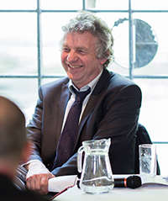

**Alison Urie**

**Director, Vox Liminis**

Alison Urie has led the development of creative arts organisation Vox Liminis. Vox Liminis is creating spaces where differently situated people affected by the criminal justice system communicate, connect and grow in new ways, experimenting with the role of the arts in how justice might be reimagined.

Prior to this Alison led the first 10 years of youth community organisation Hot Chocolate Trust, building creative community development work in a city centre context. Alongside this work she has pursued interdisciplinary studies in Youth Work and Community Learning & Development, Theology and Urban Studies.

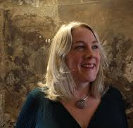

**Professor Hugo Van Woerden**

**Director of Public Health, NHS Highland**

Dr Van Woerden joined the Board of NHS Highland in February 2015 as Director of Public Health & Health Policy. He leads a range of teams that provide health protection, health improvement, public health intelligence and epidemiology, supporting the Highland Quality Approach and contributing to public health research. He has worked as a Consultant in Public Health Medicine in Scotland, England & Wales, where latterly he worked at a national level as Director of Innovation & Development with Public Health Wales. Before this he worked as a junior doctor and GP in NHS Highland and in a range of other Scottish Health Boards.

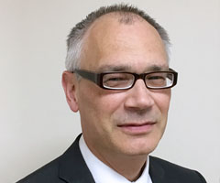

**Sean McCollum MSc, MBA, LLB (Hons) (Open)**

Sean McCollum has worked in the substance use field for 30 years.  He has fulfilled a range of duties during his career from outreach worker to Alcohol and Drug Partnership Chair.  Sean was formerly Head of Operations at the Scottish Drugs Forum and is now Policy and Development Co-ordinator with Alcohol Focus Scotland.  Sean has an Honours Degree in Law along with an MSc and an MBA