Welcome to Caithness Recovery Awareness Week
27th- 31st Aug 2018

in partnership with Caithness Drug and Alcohol Forum, Highland Alcohol and Drug Partnership, NHS Highland, Highland Council, UK SMART Recovery, AA, NA & Al-anon, Vocational Support and many more!

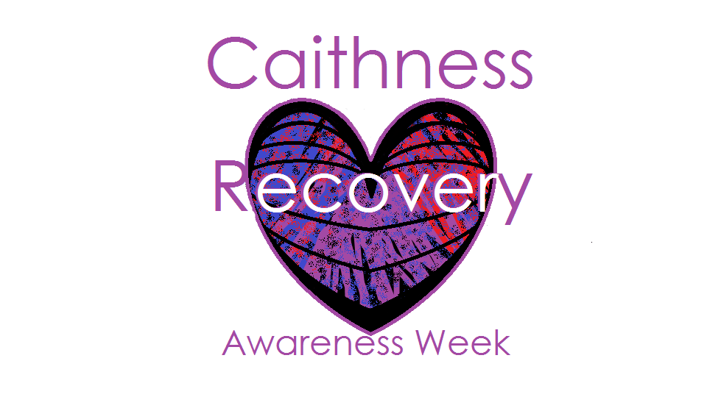

Dear Community Member

We have a full week of events planned throughout Caithness and would welcome your support and involvement. Harmful use of alcohol and drugs costs everyone in one way or another but people can and do recover. We are asking that you show others that you care about recovery locally by wearing purple for the week of 27th August 2018. If you can we would also like you to encourage others to support and celebrate recovery from alcohol and drugs, by getting them too to wear purple.

If you feel your business/ organisation could also get involved (for example by displaying posters/ leaflets, accessing training, raising money or awareness or by becoming a recovery supportive employer) please do get in touch.

Many Thanks,
Fiona Harper
Health Improvement Co-ordinator
Caithness Alcohol and Drug Recovery Service
fiona.harper5@nhs.net
01955 606915/ 01847 891224

