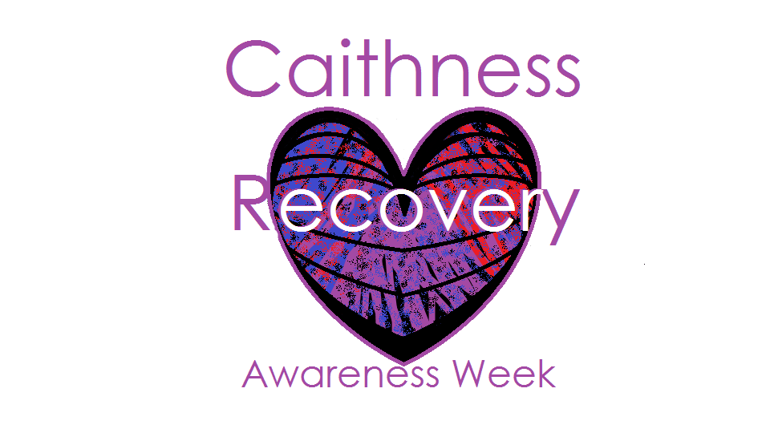

Welcome to Caithness Recovery Awareness Week

27th- 31st Aug 2018

in partnership with Caithness Drug and Alcohol Forum, Highland Alcohol and Drug Partnership, NHS Highland, Highland Council, UK SMART Recovery, AA, NA & Al-anon, Vocational Support and many more!

Activities Calendar

Thursday 30th August

**2pm-4pm** Drug and Alcohol Recovery Service Drop-in, Old Medical Centre, Bankhead Road, Wick.

**6.30pm** Narcotics Anonymous Open Meeting in The Haven, Bankhead Road, Wick.

Friday 31st August

**1.30-2.30pm** Loved and lost remembrance Norseman Hotel Wick

**3-4pm** Caithness Drug and Alcohol Forum Annual General Meeting Norseman Hotel Wick.

No booking required for any of the activities

listed, please feel free to turn up and get involved!

Activities Calendar

Monday 27th August

**6pm-8pm** Drug and Alcohol Recovery Service Drop-in Evening, Caithness General Hospital Out Patients Dept, Wick.

**8pm-9.30pm** Al-anon Family Group Open Meeting Conference Room, Caithness General Hospital, Wick.

Tuesday 28th August

**10am-2pm** Vocational Support Open Day, The Bungalow, Dunbar Hospital, Thurso.

Wednesday 29th August

**11am-1pm** Drug and Alcohol Recovery Service Drop-in, Old Out Patients Dept, Dunbar Hospital, Thurso.

**12 noon -1.30pm** Alcoholics Anonymous Open Meeting in The Chapel, Caithness General Hospital, Wick.

Training Calendar

Thursday 31st August

**Discussing Drugs and Alcohol with Young People Training** 9.30-1.00 North Highland College, Thurso.

**NPS - New/Novel Psychoactive Substances Training** 1.30 – 4.30 North Highland College, Thurso.

Friday 1st August

**Naloxone, Overdose Awareness and Prevention Training** 10.00-12.00 Norseman Hotel, Wick

**Caithness Drug and Alcohol Forum Annual General Meeting** Norseman Hotel Wick 3pm-4pm.

For all bookings please contact Fiona Harper

on 01955 606915

or email requests to [fiona.harper5@nhs.net](mailto:fiona.harper5@nhs.net)

Please note booking is essential for all training

Training Calendar

Monday 28th August

SDFs **Introduction to Trauma** 9.30-4.30 PPP, Wick.

Tuesday 29th August

SDFs **Staying Alive–Reducing drug related deaths Training** 9.30-4.30North Highland College, Thurso

Wednesday 30th August

SDFs **Older & Wiser?- Working with people who use substances as they age Training** 9.30-4.30 North Highland College, Thurso.